Magnetic LED Strips Quotation
2016 V10.0
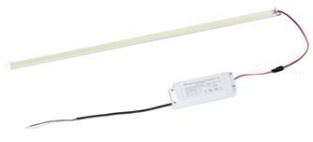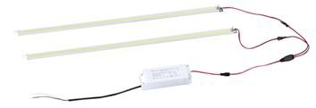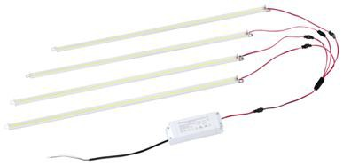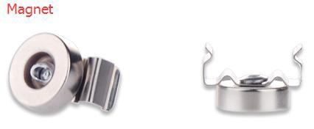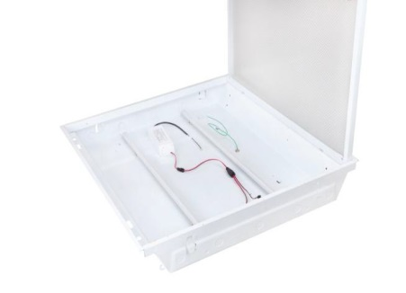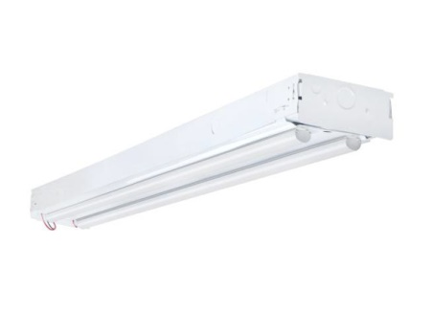
No. | ITEM | DESCRIPTION | WATTS | The price included | Lumens& Effeciency | DIMENSION
1 | WL-RTST124 | 1.AC100-277V  - LED:SMD 2835  Bridgelux  - Driver: UL Class II 4.CCT:4000K/5000K  5.Lens:Clear/Frost | 24W 1 ×Strip | 1.PCB Board with LED 2.Aluminum profile 3.2× DC Wire  4.2× Nuts  - Lens (Clear or Frost)  - L Shape bracket 7.2×Magnet per strip | 125-135Lm/W  2500-2700Lm | 4 Feet (  L44.5''×W0.71''H0.54'')
2 | WL-RTST230 |  | 30W 2×Strips |  | 125-135Lm/W  3750-4050Lm
3 | WL-RTST240 |  | 40W 2×Strips |  | 125-135Lm/W  5000-5400Lm
4 | WL-RTST345 |  | 45W 3×Strips |  | 125-135Lm/W  5625-6075Lm
5 | WL-RTST360 |  | 60W 3×Strips |  | 125-135Lm/W  7500-8100Lm
6 | WL-RTST460 |  | 60W 4×Strips |  | 125-135Lm/W  7500-8100Lm
7 | WL-RTST480 |  | 80W 4×Strips |  | 125-135Lm/W  10000-10800Lm
8 | WL-RTST2120 |  | 20W 1 ×Strip |  | 125-135Lm/W  2500-2700Lm | 2 Feet (L22.2''×W0.71''H0.54'')
9 | WL-RTST2230 |  | 30W 2×Strips |  | 125-135Lm/W  3750-4050Lm
10 | WL-RTST2340 |  | 40W 3×Strips |  | 125-135Lm/W  5000-5400Lm
1.Price Term:EX-Work 2.Quotation valid:60 days 3.Warranty 5 years
4.Non-flicker driver is avaialbe.
